Lecture 13 chapter 27

Current and resistance



Electric current: a net flow of electric charge through a region

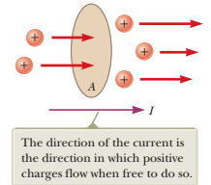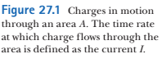

Analogy: water pipe and electric current

water in a pipe: 10 liters per minute

Consider charges moving perpendicular to the area A Figure 27.1

If ΔQ is the amount of charge that passes through this surface in a time interval Δt, the average current Iavg is equal to the charge that passes through A per unit time:



the **instantaneous current** *I* as the limit of the average current as d*t* -> 0:



SI unit of current:



**charge carrier** - moving charged particle (an electron, a proton, an ion, holes in semiconductors)



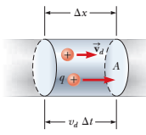

Charge in the segment of wire:







the speed of the charge carriers *vd* is an average speed called the **drift speed.**

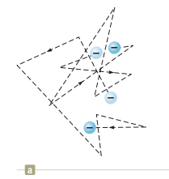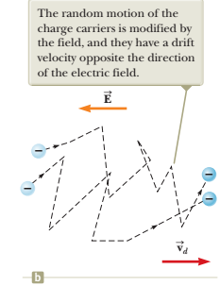

a) random motion of curriers in a conductor

b) drift of carriers in the presence of an electric field

Why electrons move in the direction opposite to $\vec{E}$?

atom–electron collisions in a conductor is an effective internal friction (or drag force) similar to that experienced by a liquid’s molecules flowing through a pipe stuffed with steel wool

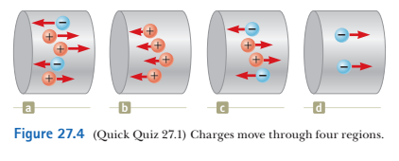

**Q** Consider positive and negative charges moving horizontally through the four regions shown in Figure 27.4. Rank the current in these four regions from highest to lowest.



The 12-gauge copper wire in a typical residential building has a cross-sectional area of 3.31 * 10-6 m2. It carries a constant current of 10.0 A. What is the drift speed of the electrons in the wire? Assume each copper atom contributes one free electron to the current. The density of copper is 8.92 g/cm3.

SOLUTION

We need to find the density of electrons in copper.

Atomic mass of Cu : M = 63.5 g/mol

Volume of 1 mole of Cu: V = M/density = M/ρ

density of electrons: n = NA/V ,

where NA is Avogadro’s number NA = 6.02 1023 mol-1



from eq 27.4:



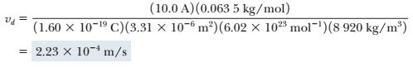



Consider a conductor of cross-sectional area *A* carrying a current *I.* The **current density** *J* in the conductor is defined as the current per unit area

I = nqvd A

Hence,

J = nqvd (27.5)

When potential difference is maintained across the conductor,

E and J are established

In many materials: J is proportional to E



σ is called **conductivity**

**Ohm’s Law:**

“For many materials (including most metals), the ratio of the current density to the electric field is a constant s that is independent of the electric field producing the current.”

Other form of Ohm’s law:

V = IR

where I is current and V is voltage. the constant R is called “resistance”

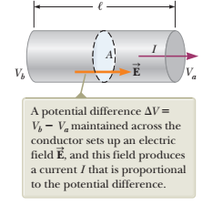







Since J = I/A





R is called “resistance”

We define resistance R as : R = ΔV /I

SI unit of current: 1 Ohm =1 Volt / 1Amper

definition of resistivity:



SI unit of resistivity : ohm m

from the formula above:



Equation 27.10 shows that the resistance of a given cylindrical conductor such as a wire is proportional to its length and inversely proportional to its cross-sectional area

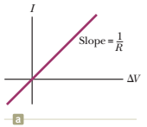 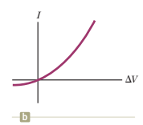

**Figure 27.7** (a) The current– potential difference curve for an ohmic material. The curve is linear, and the slope is equal to  
the inverse of the resistance of the conductor. (b) A nonlinear current–potential difference curve for a junction diode. This  
device does not obey Ohm’s law

semiconducting device with nonlinear *I*-versus-D*V* characteristics is the *junction diode*(Fig. 27.7b)

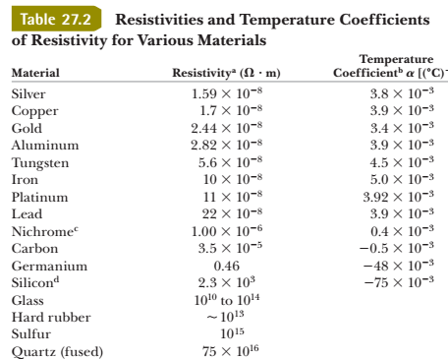



A cylindrical wire has a radius *r* and length ,. If both *r* and , are doubled, does the resistance of the wire **(a)** increase, **(b)** decrease, or **(c)** remain the same?



In Figure 27.7b, as the applied voltage increases, does the resistance of the diode **(a)** increase, **(b)** decrease, or **(c)** remain the same?



The radius of 22-gauge Nichrome wire is 0.32 mm.  
**(A)** Calculate the resistance per unit length of this wire.

resistivity of Nichrome: in the Table above



**(B)** If a potential difference of 10 V is maintained across a 1.0-m length of the Nichrome wire, what is the current in the wire?



Questions:

1. Car batteries are often rated in ampere-hours. Does  
this information designate the amount of (a) current,  
(b) power, (c) energy, (d) charge, or (e) potential the  
battery can supply?

2. Two wires A and B with circular cross sections are  
made of the same metal and have equal lengths, but  
the resistance of wire A is three times greater than that  
of wire B. **(i)** What is the ratio of the cross-sectional

area of A to that of B? (a) 3 (b) !3 (c) 1 (d) 1/ !3  
(e) 1 3 **(ii)** What is the ratio of the radius of A to that of  
B? Choose from the same possibilities as in part (i)

5.A potential difference of 1.00 V is maintained across a  
10.0-V resistor for a period of 20.0 s. What total charge  
passes by a point in one of the wires connected to  
the resistor in this time interval? (a) 200 C (b) 20.0 C  
(c) 2.00 C (d) 0.005 00 C (e) 0.050 0 C

PROBLEMS  
2. A small sphere that carries a charge *q* is whirled in a  
circle at the end of an insulating string. The angular  
frequency of revolution is v. What average current  
does this revolving charge represent?

5. A proton beam in an accelerator carries a current of  
125 mA. If the beam is incident on a target, how many  
protons strike the target in a period of 23.0 s?